ISSUES CHECK

- There is no field validation provided.[Successful message is been displayed if we click on submit without providing any of the data]
- Category, Model, Visibility are mandatory fields.
- Post Title field is not required
- Title has to be post new item
- For Categories which doesn’t include a specific manufacturer[ in the dropdown list] there should an option to select other from the dropdown

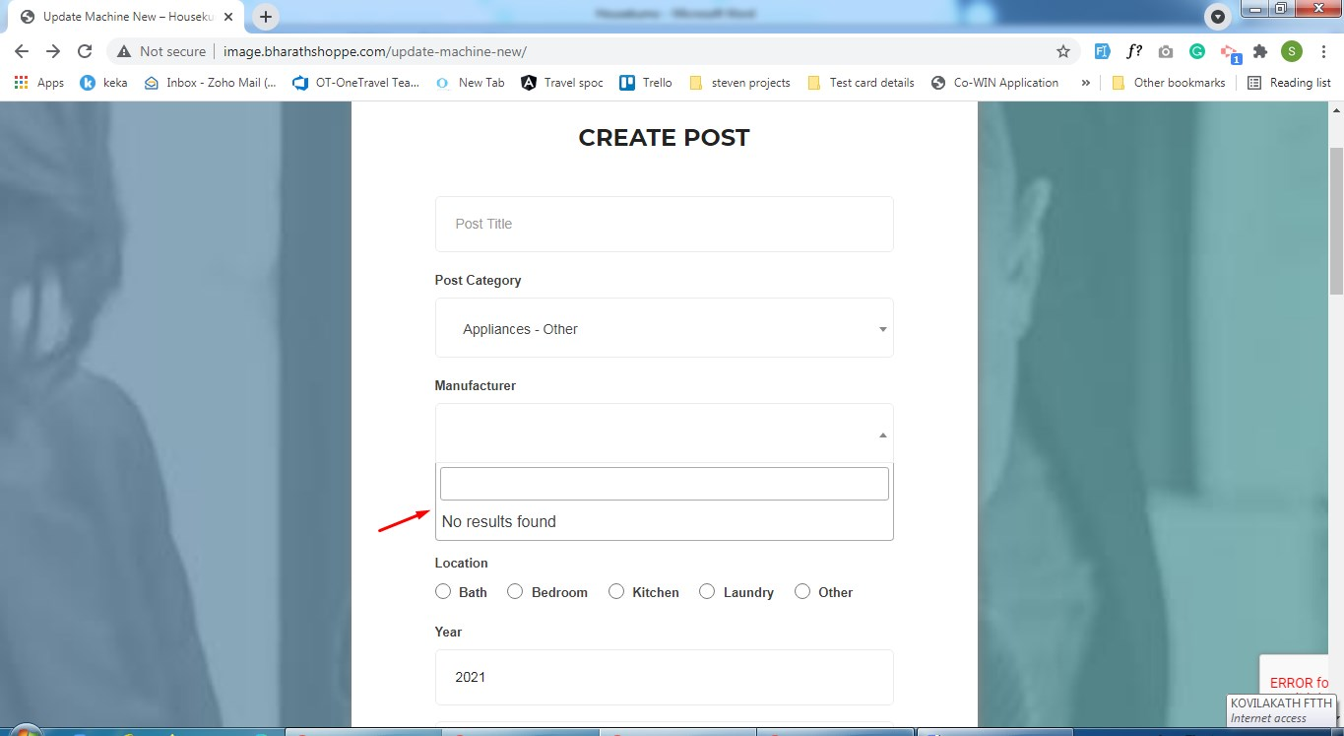

- “PLEASE SPECIFY THE MANUFACTURER” field is missing[Note : has to be a mandatory field]
- Only Manufacturers corresponding to the category selected should be displayed in the list : As of now all of them are listed in the drop down] : Check the image on edit
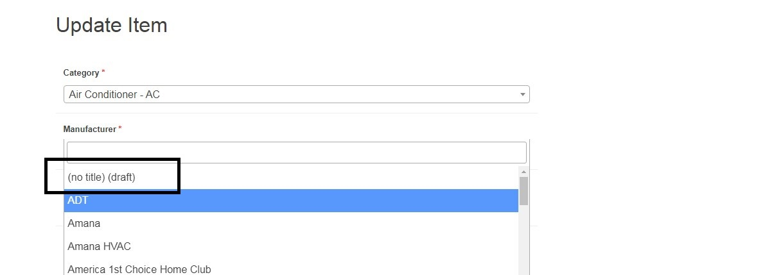

- Indication for drop down
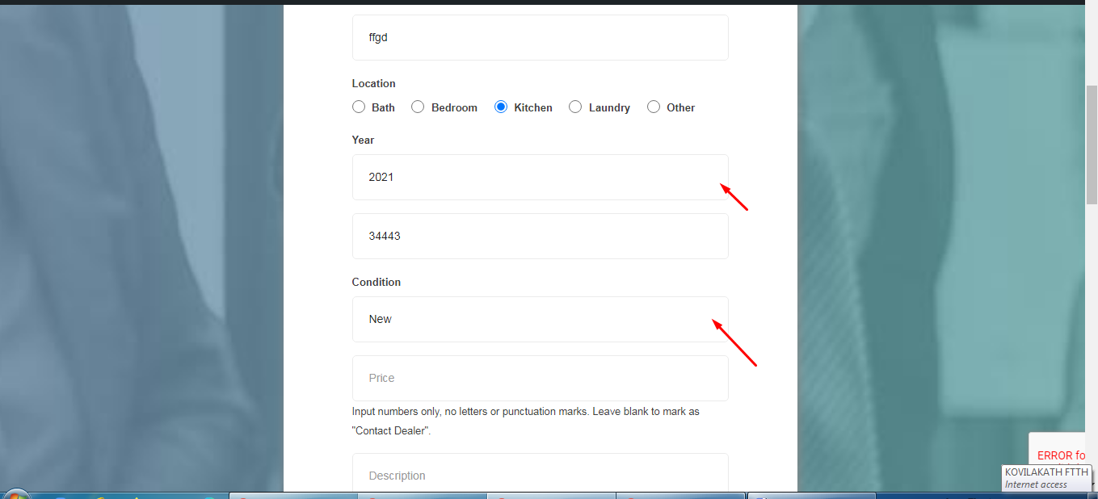

- FILE UPLOAD : File uploaded are not been displayed in the item description section[Have included invoice and manuals]

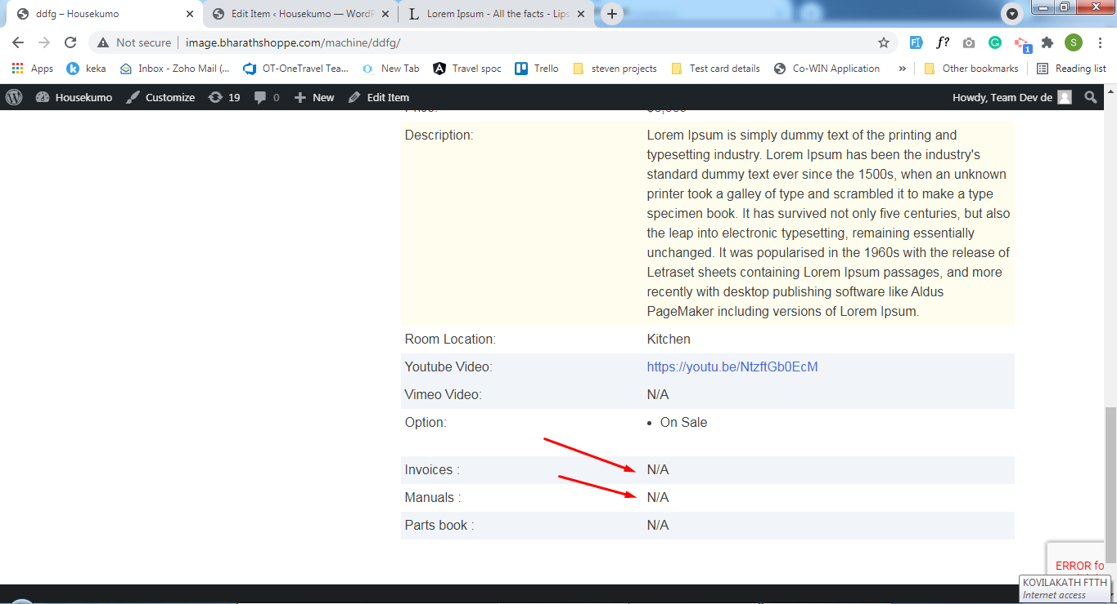
- INVOICE,MANUAL, PARTS BOOK : There has to be provision to include more than one file for each of them
- EDIT ITEM : The form should be the same while we try to edit the particular item
- Manufacturer selected from the dropdown is not displayed in the details section.[Some random no is been displayed there]

